

MUMBAI EDUCATIONAL TRUST
MET INSTITUTE OF COMPUTER SCIENCE

Program Number | 05
Roll Number | 1550
Title of program | Tableau
Objective | Tableau
Tableau
Microsoft excel ->select file (sample-superstore.xls)
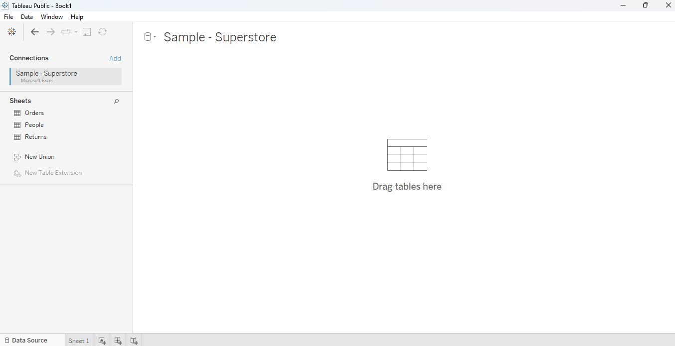
Drag orders on right side
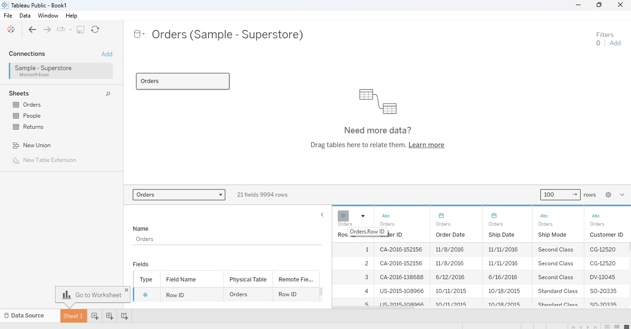
Click on sheet1
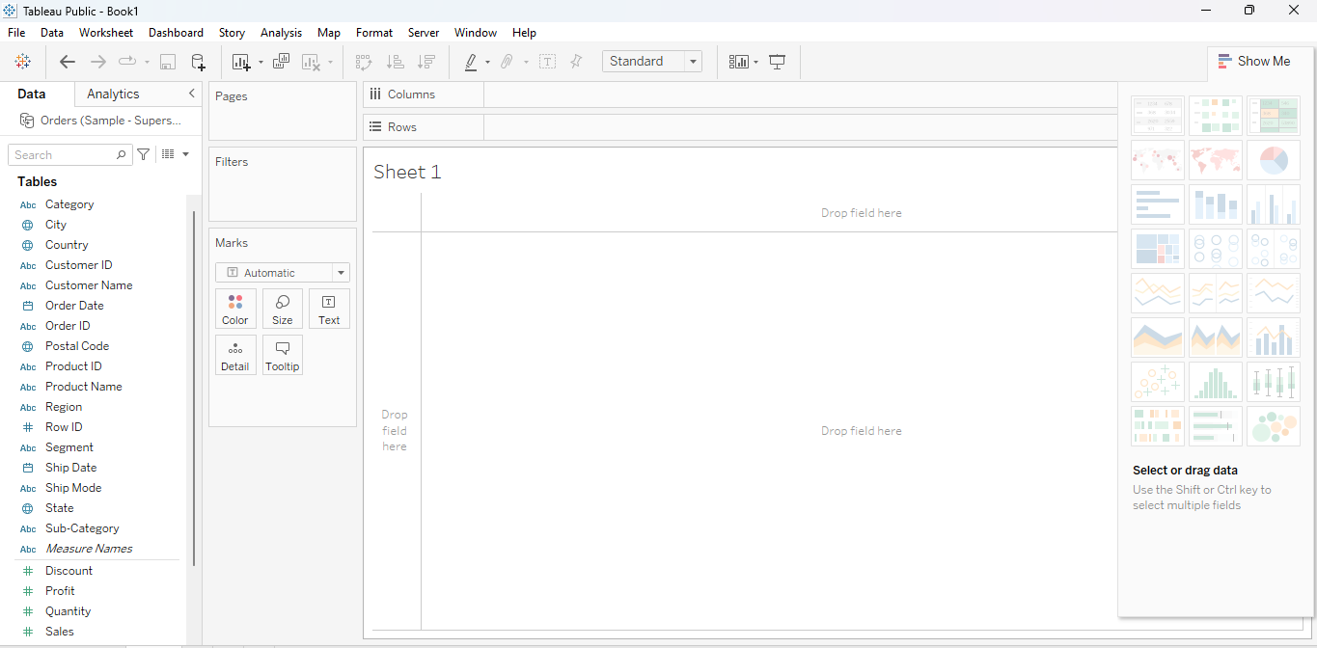
Q1.Find the customer with highest over all profit .what is her/her profit ratio?
Step 1:
Microsoft excel ->select file (sample-superstore.xls)
Step 2:
Drag orders on right side
Step 3:
Click on sheet1
Step 4:
Drag customer name in rows And column drag profit

Ascending order
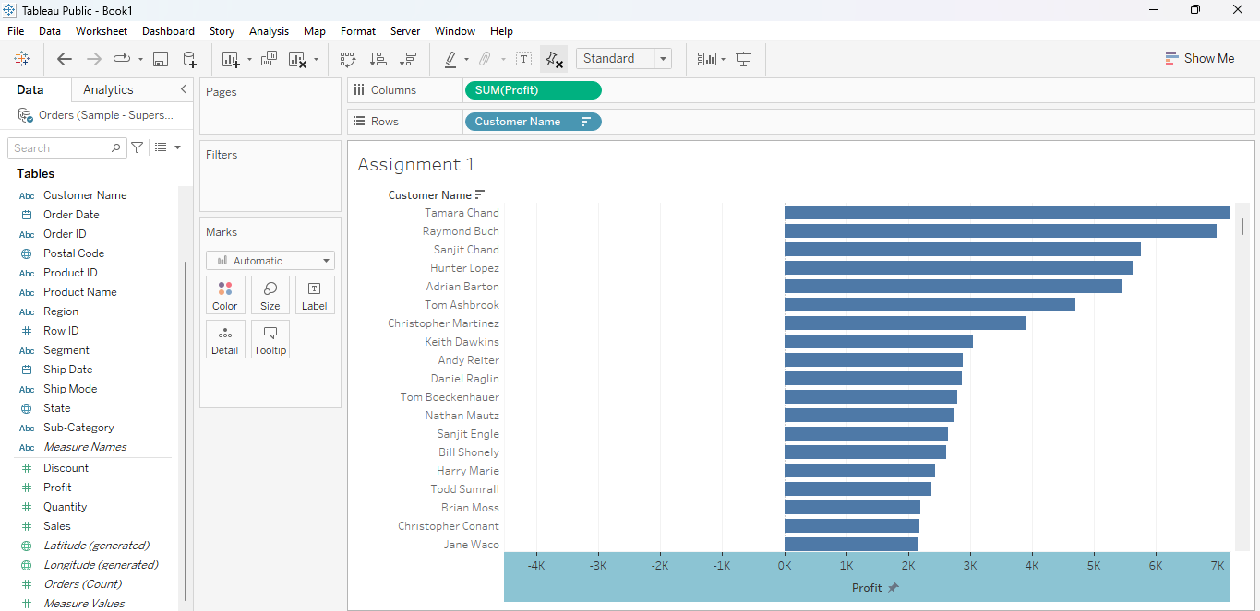

Descending order
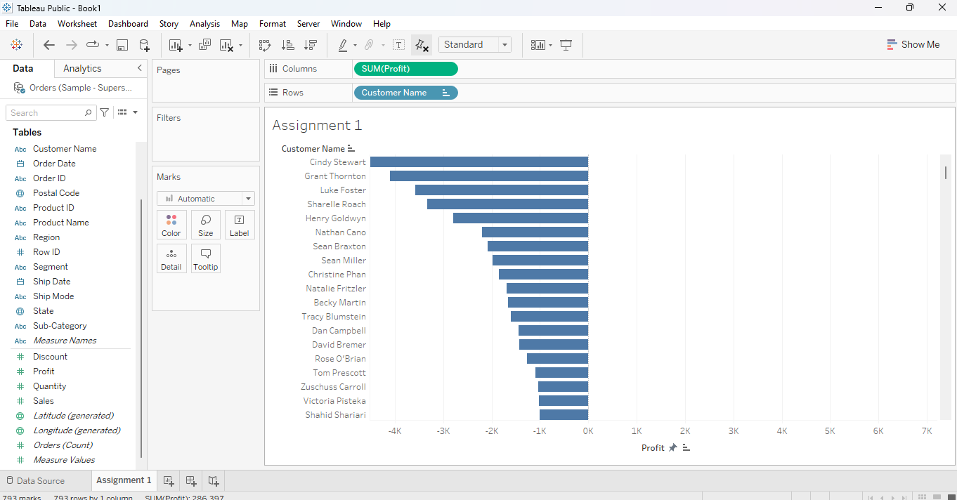

Click on analysis->create calculate field

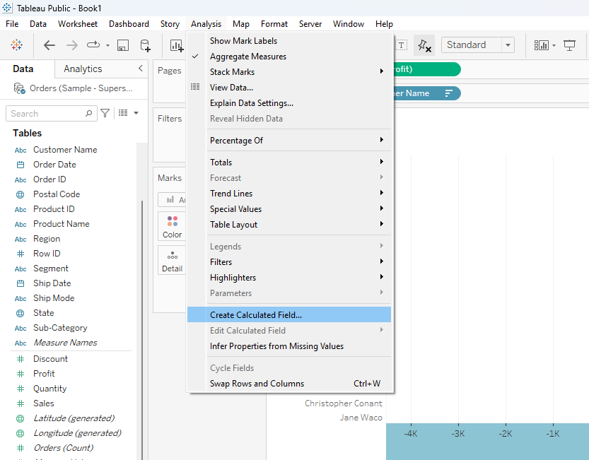
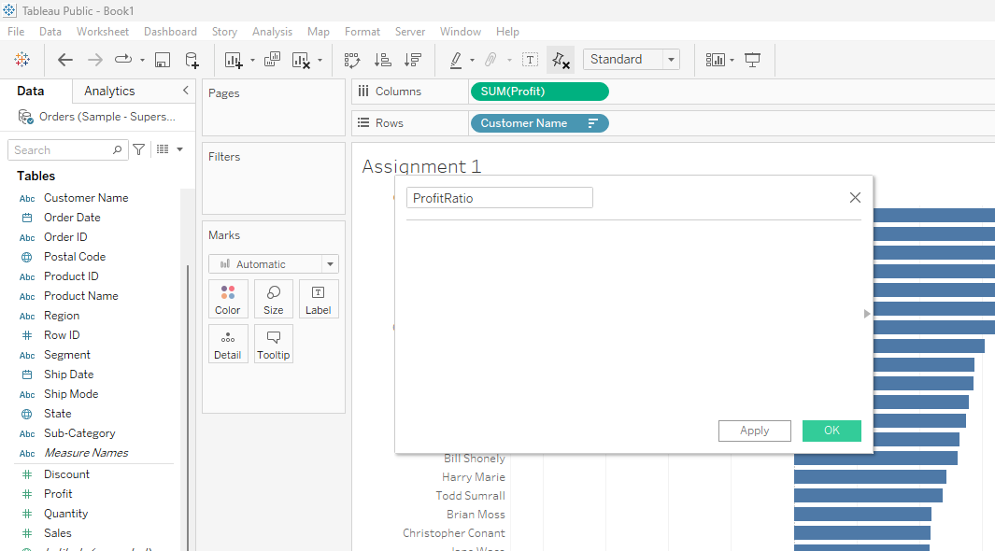

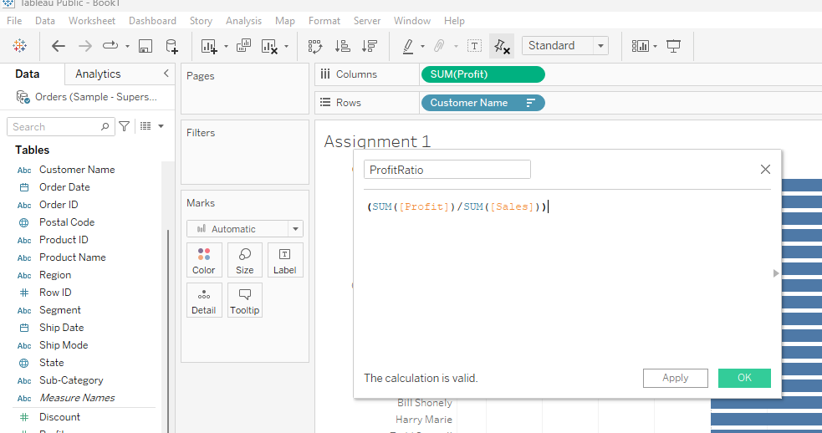
Click on OK
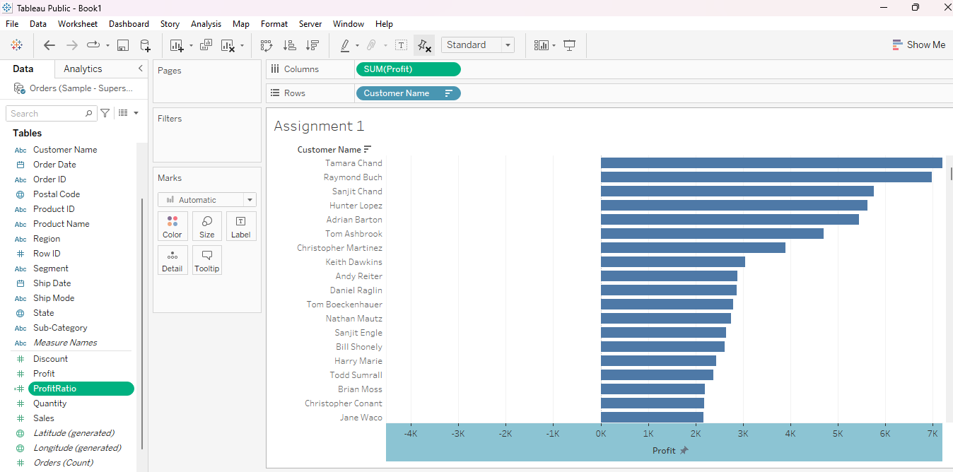

ProfitRatio Drag and drop on tooltip
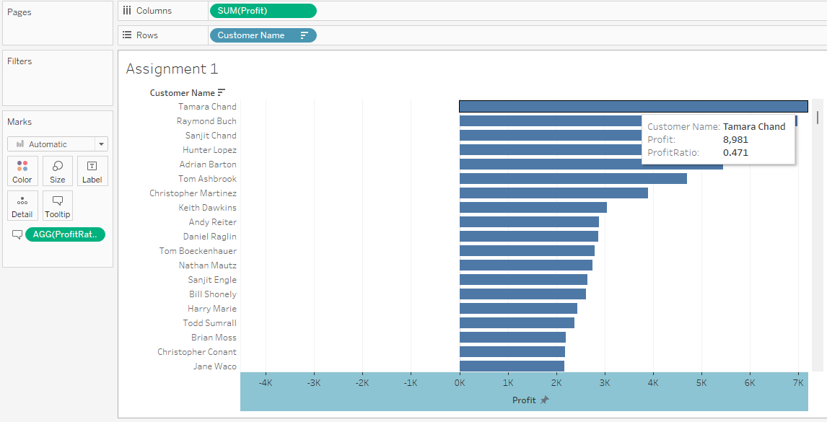

Q2.Which state has the highest Sales .what is the total Sales for that state.
Create new sheet name as assignment 2
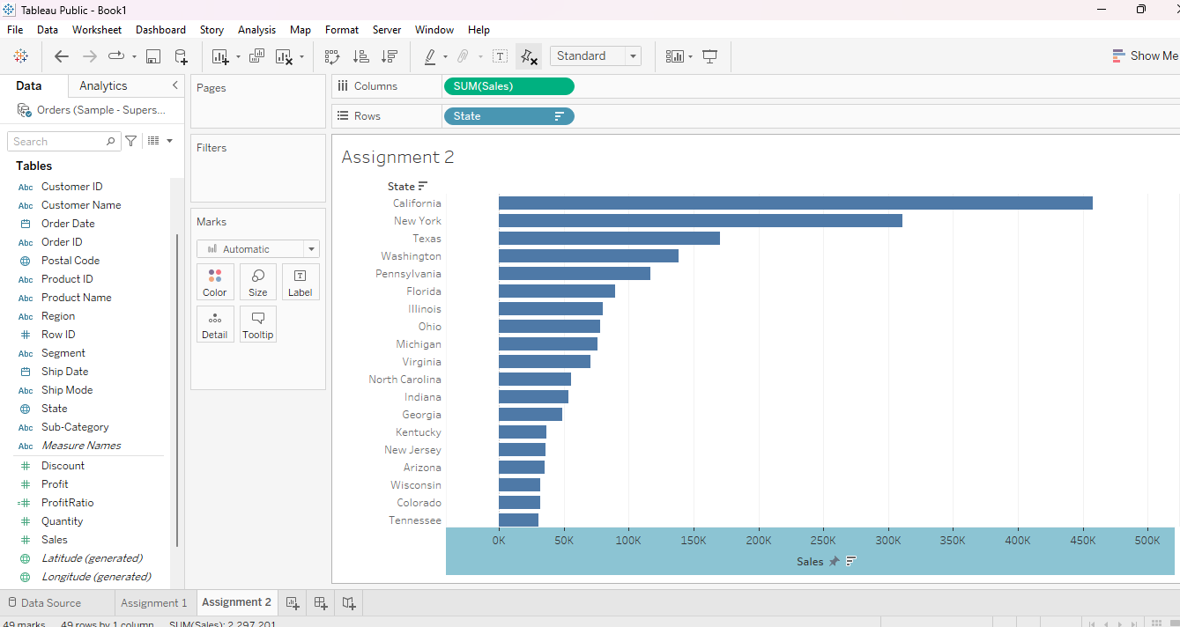
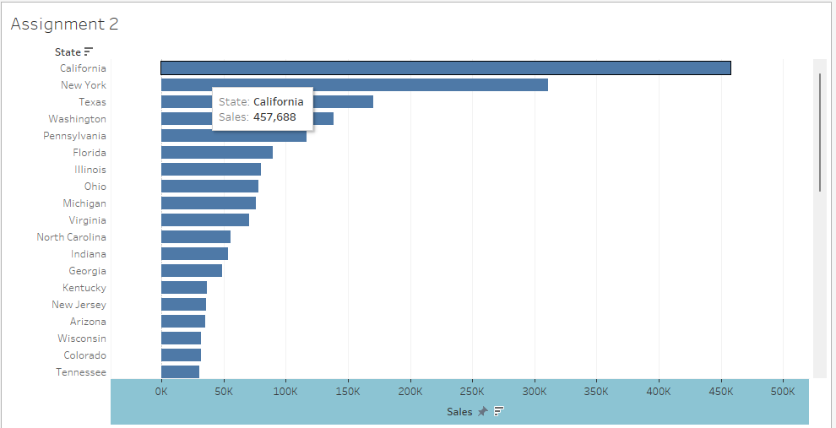

Q3.which customer segment has the highest order quantity and average discount rate for that segment?which customer
Prepare sheet Assignment 3
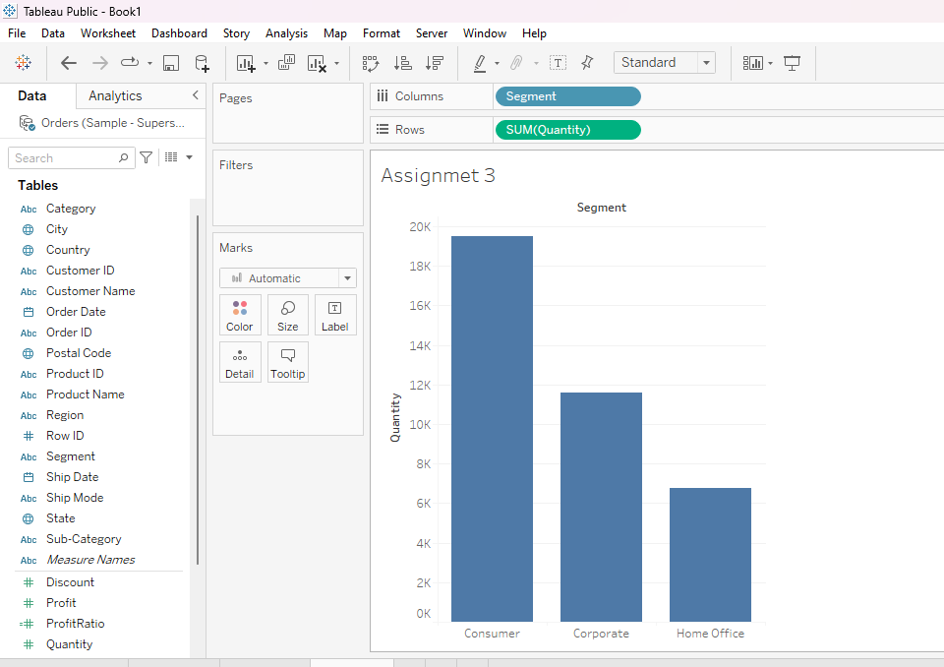

Change measure sum to avg
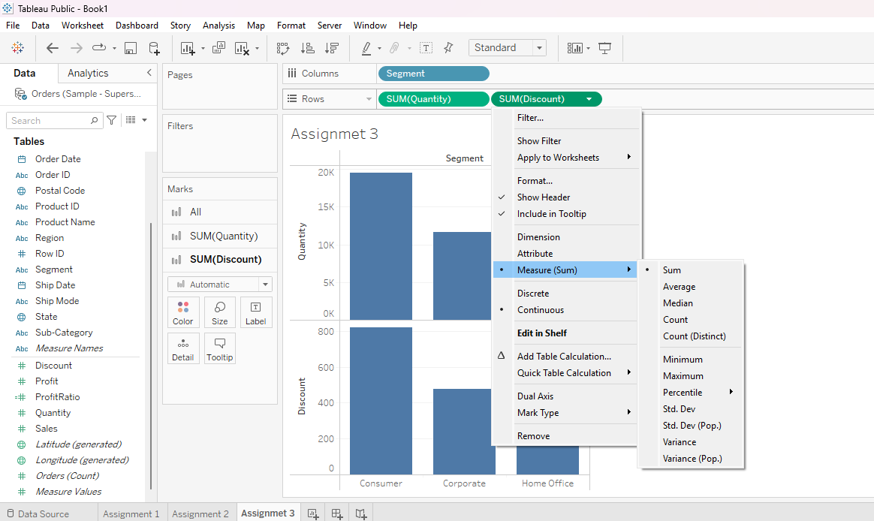
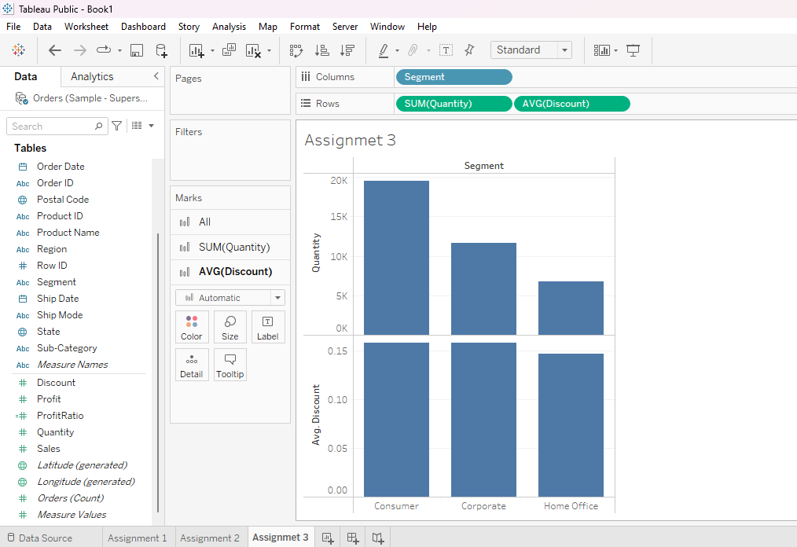

Show me select whichever you want
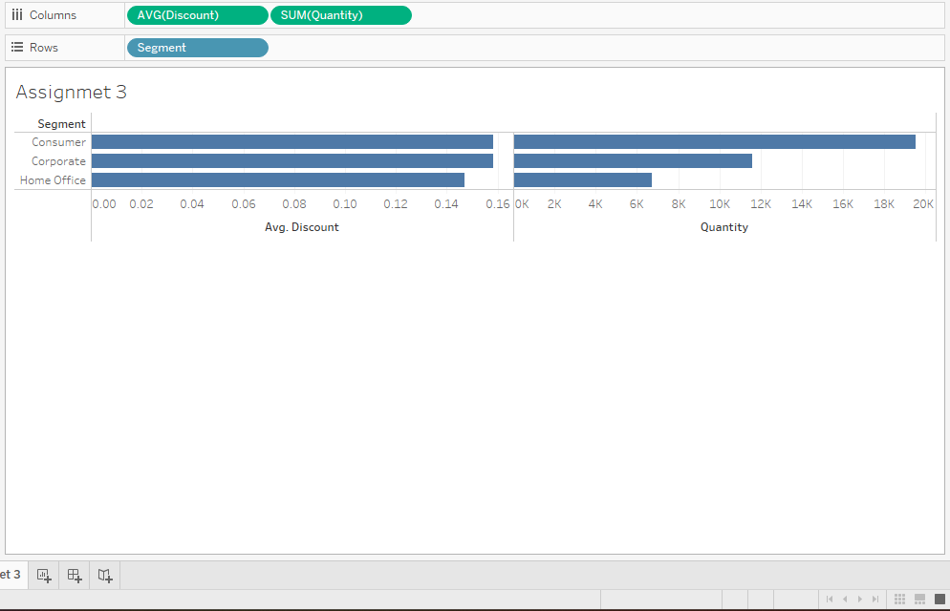
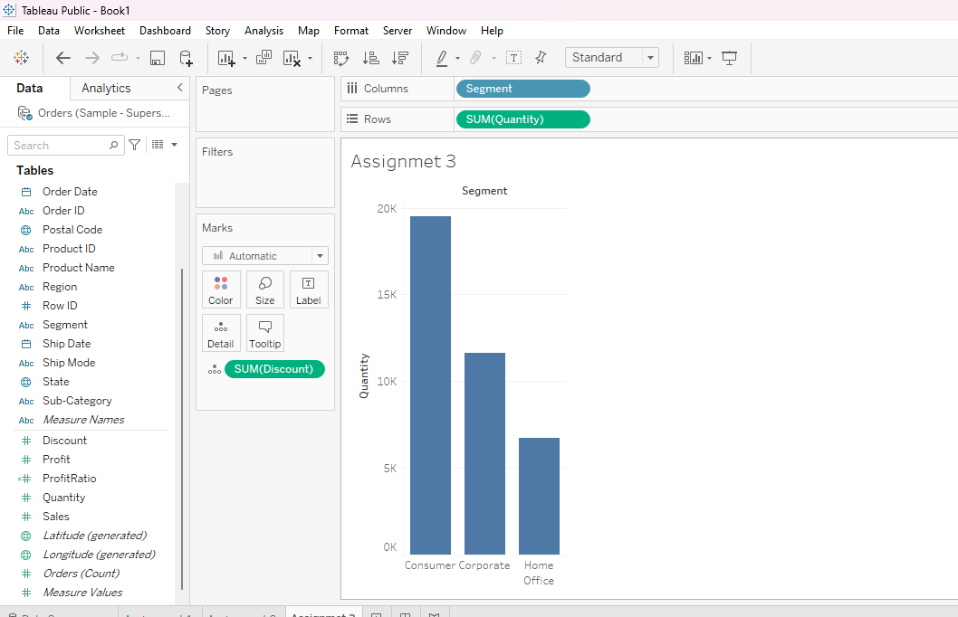

Q4.Which product category has the highest total sale ?Which product category has the worst profit?
Prepare sheet Assignment 4
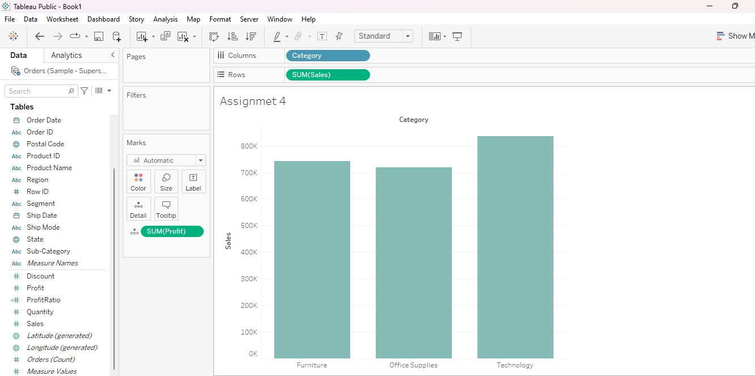
Q5.What is total sales in the Superstore dataset ?
Sale and profit drop on text
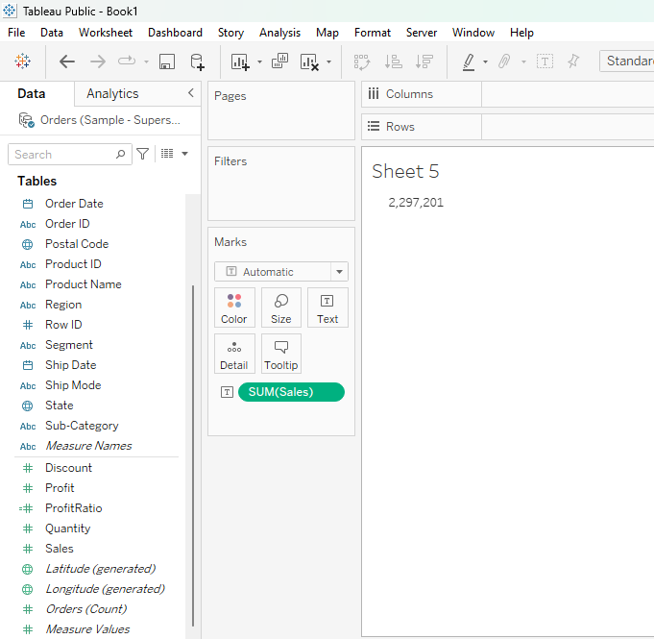

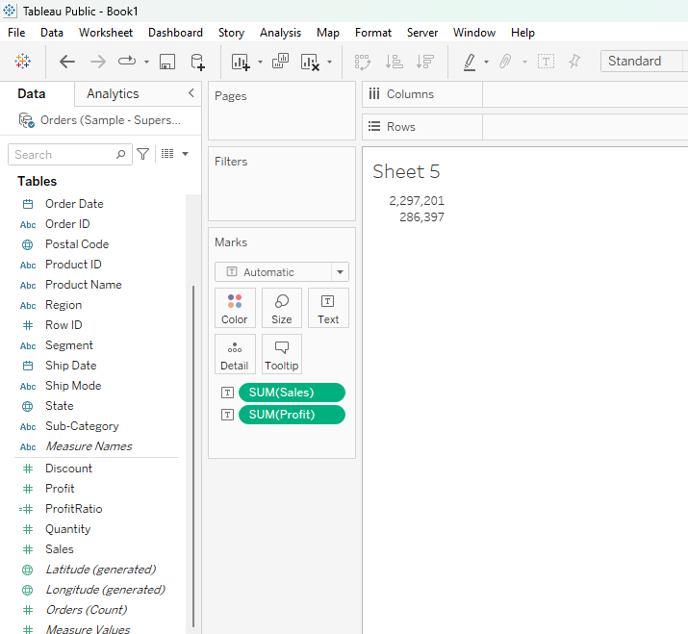
Q6 What is the trend of sales over time?
New sheet Assignment 6
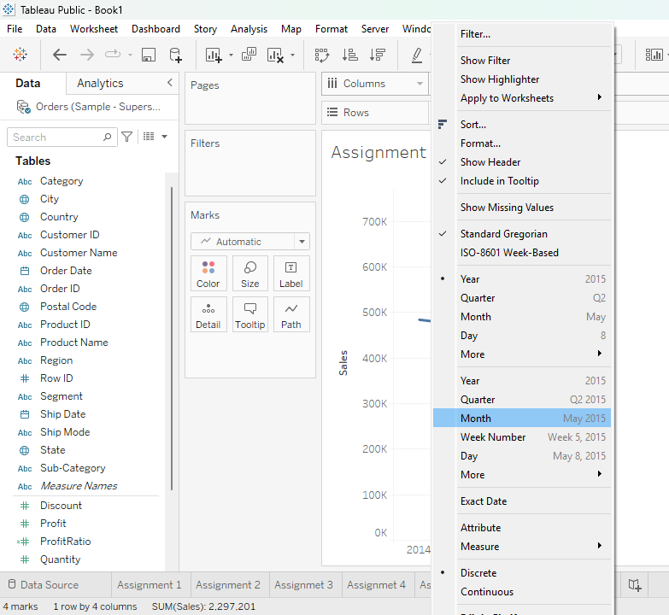
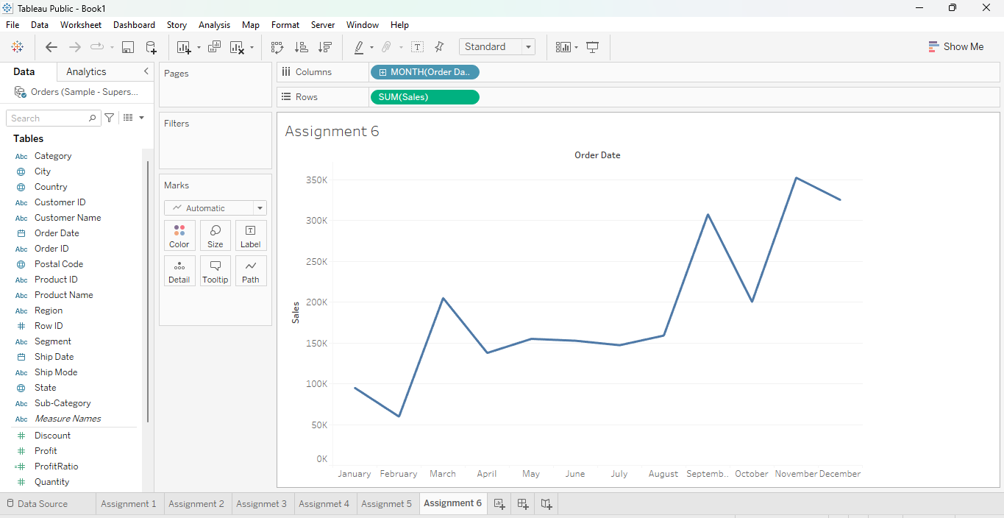

Q7.Which region contributes to more overall sales?
New sheet Assignment 7
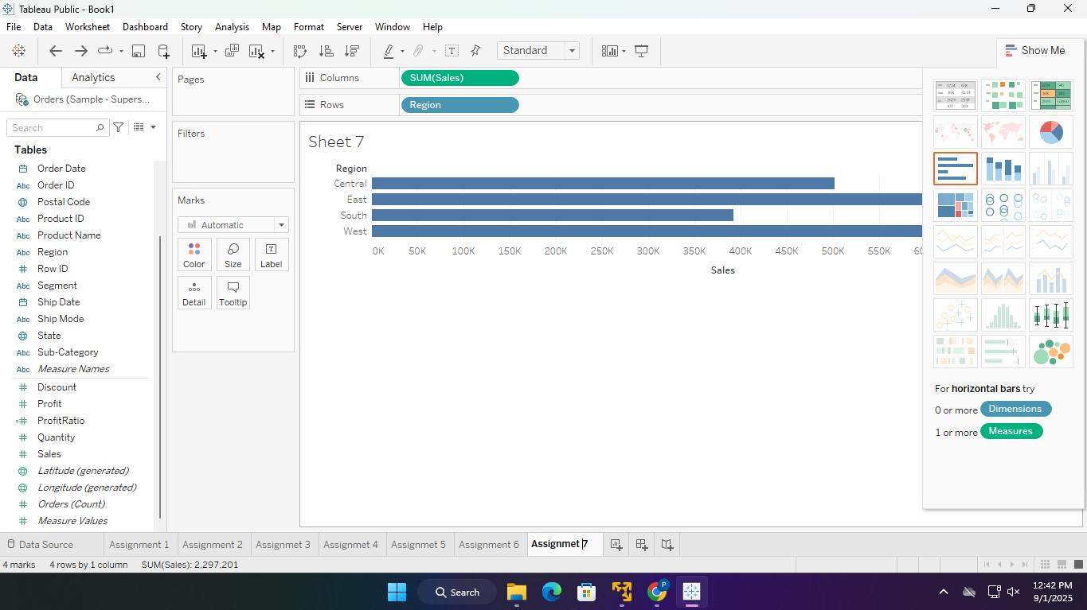

Q.8 Show the state on a map
column->state
Size ->state
color->sales
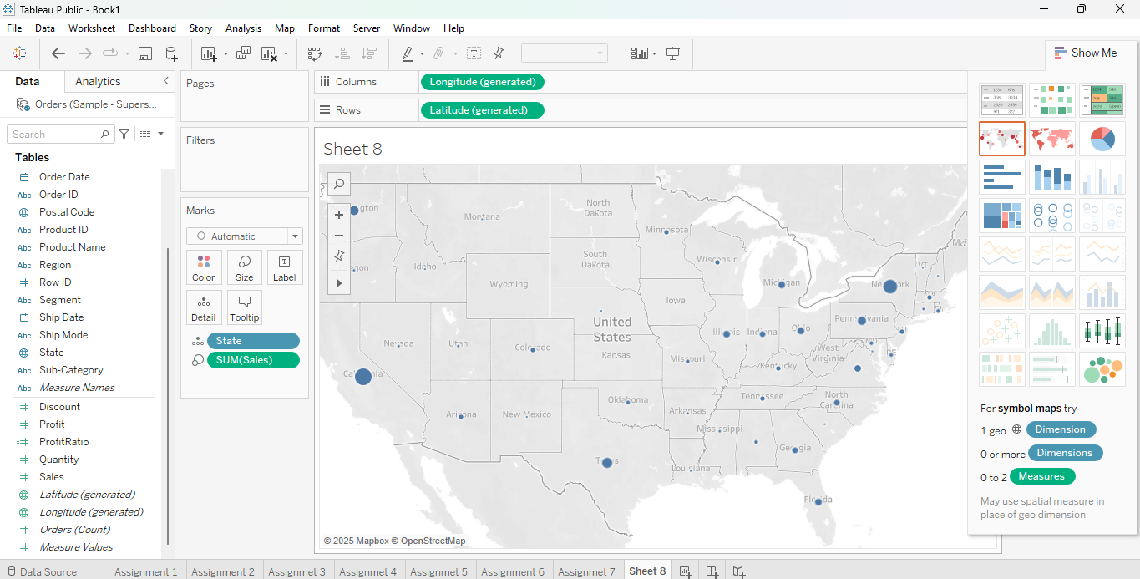
Q9.Which product department has the highest Selling cost?
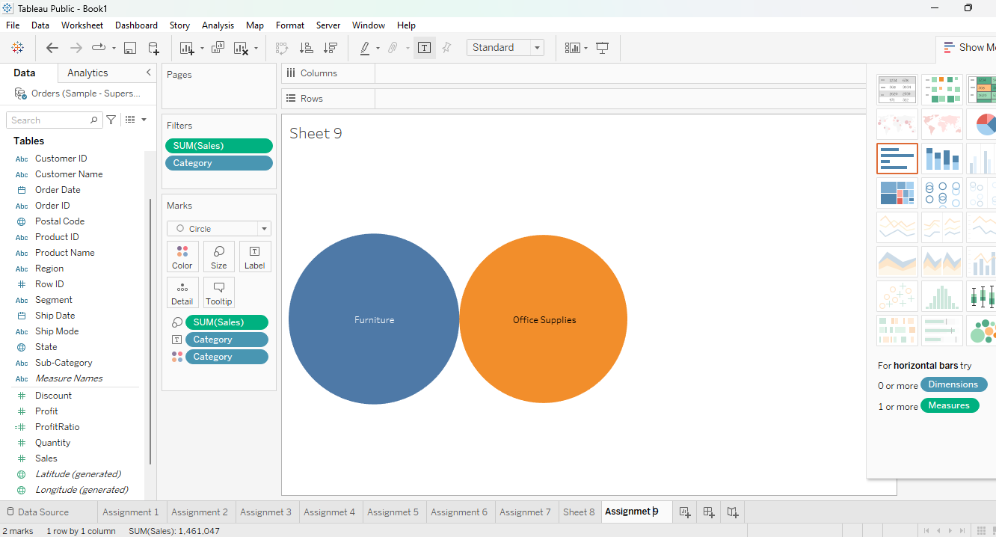

Q10.Top 10 customers?

Drag Customer Name → Rows

Drag Sales → Columns

Customer name ->filter->top->
